Master of Computer and Information Sciences

ASSIGNMENT COVER SHEET - INDIVIDUAL
Student Name and ID: David Kaufmann, 0826510
Date: 4 June 2009
Paper Name and Code: Research Methods 1, 408220
Assignment Name: Project Report | Number of Words/Pages: 17 / 4237

In order to ensure fair and honest assessment results for all students, it is a requirement that the work that you hand in for assessments is your own work.

Please read and place an “X” in the boxes below to confirm that the statements are true of the work you are submitting.

Where I have used someone else’s words, I have indicated this (using quotation marks and adding the reference). Where I have used other people’s ideas or writing, I have indicated this by putting them into my own words and adding the reference. |  | X
Other than this, this assignment:
IS NOT copied from another student or from a previous assignment. | X
IS NOT copied from books, journals, Web pages or other sources. | X
HAS NOT been handed in by me or anyone else in any other course. | X
IS WRITTEN BY ME as the sole author | X
Complete this section only if the assessment is being submitted after the original assessment deadline
Extension granted? YES / NO
If an extension was granted, by whom: .........................…………………(name),

and until when: ..................... (date & time)

By filling out the form and submitting it electronically I confirm that it is a true and accurate statement about me, the named student.



Data Visualisation

Project Report

David Kaufmann
(Student ID: 0826510)

4 June 2009

Philip Carter
Research Methods 1
(Paper ID: 408220)

4237 Words

Abstract
Pie charts and bar charts are two of the most frequently used data visualisation methods. This research project has studied the efficiency of these two chart types when applied to a specific set of raw data. The study conducted two surveys where a total of twelve users had to complete the same set of questions based on one of the two chart types. The replies where then analysed and tracked back to the initial research questions. The empirical evidence found during this research project suggests that both chart types have their advantages respectively disadvantages. In particular, bar charts are superior when numbers need to be presented and compared and pie charts when the representation of percentage is important. Overall, the bar chart seems to be the slightly better visualisation method as it has been proven to produce more correct user replies. The study also concludes that an enhancement of the charts with numbers should be considered in order to improve the usability.
Table of contents
1. Introduction 5
2. Research question 5
2.1. High level research question 5
2.2. Sub research questions 6
3. Research Design 6
3.1. Build and implementation of survey (Phase 2) 7
3.1.1. Structure of survey 7
3.1.2. Survey questions 7
3.2. Execution of survey (Phase 3) 8
3.2.1. Users 8
3.2.2. Course of survey 8
3.3. Analysis of survey outcome (Phase 4) 9
3.4. Documentation of findings (Phase 5) 9
4. Findings, Evidence & Analysis 9
4.1. Representation of numbers 9
4.2. Representation of percentage 10
4.3. Representation of overall numbers 11
4.4. Representation of number of subsets 12
5. Discussion 13
6. Limitations 14
6.1. Number of users 14
6.2. Overall number 14
7. Possible future work 15
7.1. Online survey 15
7.2. Different data representation methods 15
8. Reflections 16
8.1. Type of survey 16
8.2. Preparation of survey 16
8.3. Other reflections 16
9. References 17

Table of Figures
Figure 1. Application of raw data to pie chart (left) and bar chart (right) 5
Figure 2. High level approach 6
Figure 3. Enhanced bar chart 14
Figure 4. Possible bar charts for additional survey questions 14
Figure 5. Application of alternative bar chart on test data. 15

- Introduction
This project has studied the efficiency of pie charts and bar charts in order to visualize a particular set of raw data which represents the student rolls for two Universities (see Table 1 below). The used raw data has been specifically created and tailored towards the research questions.
Origin of Students |  | University A |  | University B
Colour | Country | # | % | # | %
 | China | 120 | 25.00 | 120 | 50.00
 | India | 114 | 23.75 | 38 | 15.83
 | European Union | 60 | 12.50 | 30 | 12.50
 | United States | 51 | 10.63 | 34 | 14.17
 | Indonesia | 54 | 11.25 | 0 | 0.00
 | Brazil | 24 | 5.00 | 18 | 7.50
 | Pakistan | 57 | 11.88 | 0 | 0.00
 | Total | 480 | 100.00 | 240 | 100.00
- Data displayed in table (raw data)
The application of the above raw data to pie charts and bar charts results in the two charts as depicted in Figure 1 below.
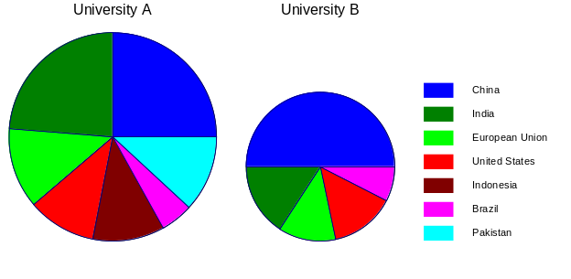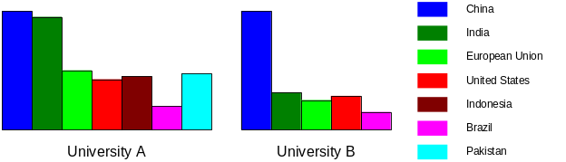
- Application of raw data to pie chart (left) and bar chart (right)
This research project investigated the efficiency of two very widely used data visualisation methods. It is believed that the results will provide some interesting insights for IT professionals who need to apply and/or understand pie charts and bar charts in various circumstances.
- Research question
  - High level research question
The high level research question for this project is:
> Which data visualisation method (pie chart or bar chart) is more effective to display a particular set of raw data (data about number of students and their country of origin within two universities).
The findings in regards to the high level research question will be discussed in chapter 5.
  - Sub research questions
In order to provide a sufficient answer, the high level research question has been divided further into the following sub research questions:
- RQ1a: Which visualisation method does better display the number for a particular subset?
- RQ1b: Use of pie chart: Are users able to compare the size of slices between two charts and therefore correctly judge the number of a subset?
- RQ2a: Which visualisation method does better display the percentage for a particular subset?
- RQ2b: Use of bar chart: Are users able to compare the size of bars in a chart and therefore correctly judge the percentage of a subset?
- RQ3: Which visualisation method does better display relatively small differences in number?
- RQ4: Which visualisation method does better display relatively small differences in percentage?
- R5: Can a user recall differences in numbers for charts seen previously?
- R6: Can a user recall the number of subsets for charts seen previously?
As highlighted in the project proposal, these sub questions link directly back to the requirements for data visualisation methods and forward to the survey questions. The findings and evidence for these sub research questions will be presented in chapter 4.
- Research Design
As shown in the high level approach below, the research project centred around a survey which has been conducted in consideration of the methodologies lied out in the project proposal.
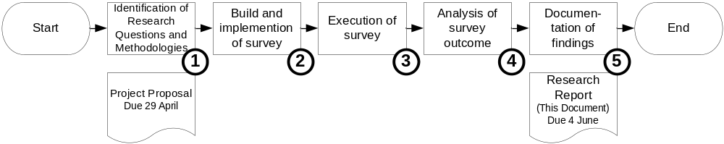
- High level approach
The detailed approach and used methods have been described in the project proposal. This chapter does not reiterate this information but does add more details and highlight deviations from the initial plan where appropriate. Also, no additional information is given about Phase 1 (Identification of Research Questions and Methodologies) as this phase was tied to the project proposal and is therefore outlined in that document.
  - Build and implementation of survey (Phase 2)
    - Structure of survey
During the work on phase 2, the two following tasks have been conducted in parallel:
- Task 1
Build of an initial paper based version of the survey according to the methods and methodologies outlined in the project proposal. Execution of further pilot tests in order to make final adaptations if necessary.
- Task 2
Search for a suitable online survey tool which allows for the implementation and execution of the survey as outlined in the project proposal. Implement the survey into the tool.
The execution of the above two tasks highlighted two issues which have not, respectively only partially been detected during phase 1. These are:
- Issue 1
The subsequent pilot tests highlighted that the written explanations about how to read the charts were not well understood by the users.
> Implication: It is absolutely crucial that the users understand the charts as the research project focuses on how well a certain data visualisation method can represent data, not on how widely it is known.
> Mitigation: Switch to a paper based face to face survey where it can be verified prior to the commencement of the survey that the user has understood how to read the charts.
- Issue 2
The analysed online surveys tools did either not provide a function for the measurement of the response time or they did not provide this function for free.
> Implication: Response time is seen as a crucial parameter since it has been used in many professional structured studies, e.g. Purchase (2000).
> Mitigation: Switch to a paper based face to face survey where the measurement of the response time is possible.
Note: This issue has been anticipated and described in the risks section of the project proposal.
Due to the above issues, the initial paper bases survey has been further developed into the main tool for data collection that has been used during this research project. It is assumed that this mitigation does not present any limitations.
    - Survey questions
The survey questions have been split into four groups and tailored towards the research questions as outlined in the project proposal. The final survey consisted of the following four sections:
- Section 1 (Multiple choice questions about chart. User has chart in front of him / her).
Four questions directly linked to research questions. Two questions asked about the visibility of percentage, two questions about the visibility of numbers.
- Section 2 (Multiple choice questions about chart. User does not have chart in front of him / her).
Two questions directly linked to research questions. The questions asked about the visibility of overall number and number of subsets.
- Section 3 (multiple choice questions about user’s perception)
Five multiple choice questions which all had the same answer possibilities and allocated score (in brackets): Strongly agree (5), Agree (4), Neutral (3), Disagree (2) and Strongly disagree (1). A score of five always gave a strong indication of effective data visualisation. This approach allowed for an easy calculation of the overall score and comparison of the results between the two different visualisation methods. Four questions were directly linked to research questions while the remaining question asked for the users overall perception about the suitability of the applied data representation method for the given raw data.
- Section 4 (Open questions).
Two questions where the user could make comments and/or suggestions about the given chart and the survey.
  - Execution of survey (Phase 3)
    - Users
The survey has been conducted with 12 users, out of which six did the bar chart and the other six the pie chart survey. All users were AUT MCIS students and enrolled in the Research Methods 1 paper.
    - Course of survey
The survey consisted of various steps as outlined below:
- Step 1: Instructions
Prior to the survey, the user has been given written and verbal instructions. Attention has been paid to explain how to read the given chart, especially how to read the percentage out of the bar chart and the number out of the pie chart. This has in each case been explained by an example taken out of the given chart. Feedback has been taken from the user whether he/she has understood the chart. The verbal instructions were a deviation from the methodologies outlined in the project proposal. However, it has been regarded as necessary in order to mitigate issue 1 (see chapter 3.1.1)
- Step 2: Execution of Section 1
The user has been verbally asked the four questions of section 1, which he/she answered while looking at the chart. The response time measurement started from the time when the formulation of the question was completed. The moderator has recorded the given answer and the response time.
- Step 3: Execution of Section 2
The chart has been taken away and the user has been verbally asked the two questions of section 2, which he/she answered by remembering the chart seen before. The response time measurement started from the time when the formulation of the question was completed. The moderator has recorded the given answer and the response time.
- Step 4: Execution of Sections 3 & 4
The users have been asked to complete section 3 & 4 of the survey by themselves. No time measurement or time restrictions applied.
- Step 5: Discussion with user (optional)
Upon request by the user, the purpose of the study, the used methods and methodologies etc. have been discussed.
  - Analysis of survey outcome (Phase 4)
All results have been recorded in Microsoft excel. One sheet with consistent layout has been used for section 1 & 2, one for section 3 and section 4 responses have been recorded in another spreadsheet. In order to facilitate the analysis, various calculations have been performed, for example median response time for section 1 and 2 or median score for section 3. Some of the detailed results are shown and explained in chapter 4.
  - Documentation of findings (Phase 5)
The findings have been presented in chapter 4 of this document. Chapter 5 then discusses the findings and provides an answer to the overall research question.
- Findings, Evidence & Analysis
The following subchapters are grouped around the findings in regards to the representation of numbers (subchapter 4.1), the representation of percentage (subchapter 4.2), the representation of total numbers (subchapter 4.3) and the representation of number of subsets (subchapter 4.4).
  - Representation of numbers
Research Questions
The following research questions cover the representation of numbers.
- RQ1a: Which visualisation method does better display the number for a particular subset?
- RQ1b: Use of pie chart: Are users able to compare the size of slices between two charts and therefore correctly judge the number of a subset?
- RQ3: Which visualisation method does better display relatively small differences in number?
Findings
Section 1 of the survey has shown that the users of the bar chart survey were more likely to correctly judge a number and that they could response in the same time or even faster than the pie chart users (when comparing the medium time for correct answers). Overall, the correct answer rate for bar chart users was very high (10 out of 12). Also, section 3 clearly showed that the users of the bar chart survey perceived their visualisation method more suitable for the presentation of numbers (score difference of 1.5 points). Table 2 below shows the finding in regards to this research question.

Empirical Evidence
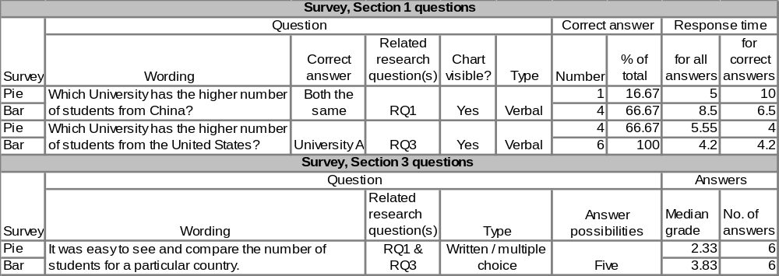
- Empirical evidence in regards to visualisation of numbers
Analysis
The outcome of the survey has reinforced common assumptions and provided strong evidence that bar charts are superior in regards to representing numbers. On the other hand, it proved to be difficult for users of the pie chart to correctly judge the number in a comparison between two pies. This was particular obvious for the two pies which represented the number of students from China. Both pies had the same area but the angle for the pie which represented University B was double of the pie which represented University A (90 vs. 45 degrees).
  - Representation of percentage
Research Questions
The following research questions cover the representation of percentage.
- RQ2a: Which visualisation method does better display the percentage for a particular subset?
- RQ2b: Use of bar chart: Are users able to compare the size of the bars in a chart and therefore correctly judge the percentage of a subset?
- RQ4: Which visualisation method does better display relatively small differences in percentage?
Findings
Section 1 of the survey has shown that the users of the pie chart survey were more likely to correctly judge a number while this was only once the case in the bar survey. However, the pie chart still attracted numerous wrong answers. Further, there was no clear trend in terms of response time. In addition, section 3 showed that the users of the pie chart survey perceived their visualisation method more suitable for the presentation of percentage (score difference of 0.84 points). Table 3 below shows the finding in regards to this research question.

Empirical Evidence
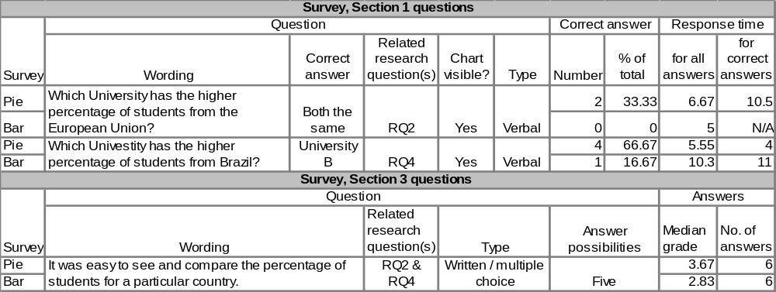
- Empirical evidence in regards to visualisation of percentage
Analysis
As expected, the pie chart is the better visualisation method for this task. However, the pie charts superiority for percentage representation seems to be slightly less accented than the bar charts superiority for number representation. This is highlighted by the fact that still 50% the questions have been answered wrongly by the pie chart users. An analysis of the response time was not possible since only one of the bar chart users managed to give the correct answer. This does not give enough response time samples to compare against. An increased number in survey participants could provide additional data.
  - Representation of overall numbers
Research Question
The following research question covers the representation of overall numbers.
- RQ5: Can a user recall differences in numbers for charts seen previously?
Findings
Section 1 of the survey has shown that a high number of users from both surveys could correctly answer the given question. The response time was higher for users of the bar chart survey. Section 3 showed that the users of the bar chart survey perceived their visualisation method slightly less suitable for the presentation of the overall number. (score difference of 0.17 points). Table 4 below shows the finding in regards to this research question.

Empirical Evidence
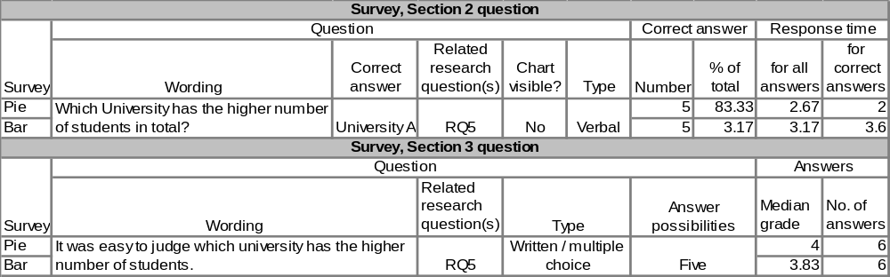
- Empirical evidence in regards to overall numbers
Analysis
The findings in regards to this research question came as a surprise since the pilot tests and self-experiment indicated a clear preference towards the pie chart, which was expected to better visualise the differences in area. It is assumed that the two following factors might have contributed to the better than expected visibility of overall numbers in the bar chart:
- A high difference in overall numbers (ratio 1:2)
- The fact that the bar chart with the higher overall number (University A) was also wider than University B (due to two additional bars)
It is assumed that there would be a more clear result in favour for the pie chart if the two above factors would be different. However, further study is needed in order to prove this assumption.
  - Representation of number of subsets
Research Question
The following research question covers the representation of number of subsets.
- RQ6: Can a user recall the number of subsets for charts seen previously?
Findings
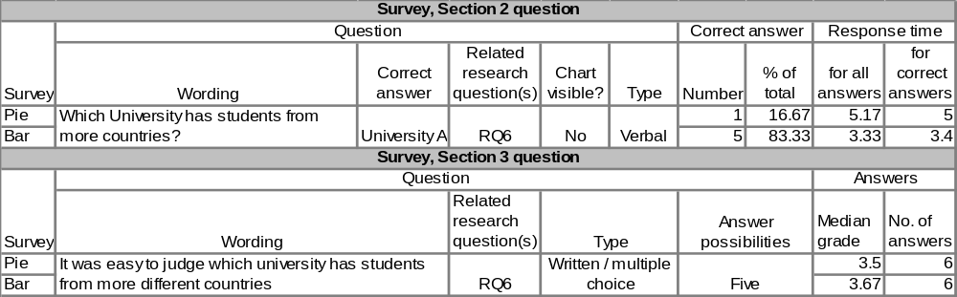
- Empirical findings in regards to numbers of subsets
Analysis
The findings clearly show that the bar chart is superior in presenting the number of subsets. This is likely due to the fact that the chart with the higher number of subsets is wider than the one with the lower number of subsets. Surprisingly, the users perceived the bar chart only slightly better, what indicates a difference between perceived and actual use.
- Discussion
This chapter summarizes the results and tries to give and answer to the overall research question.
Summary of results
The survey reinforces common assumptions and provides strong evidence that pie charts are superior in representing percentage while on the other hand, bar charts are superior in representing numbers. Also, the survey gives some indication that pie charts slightly better represent total numbers where bar charts better represent number of subsets. However, it needs to be mentioned that the pie charts superiority in regards to total numbers presentation is marginally and could only be proven by the shorter user response time. However, it is assumed that pie charts can highlight smaller difference in total number better.
Calculated overall results
The calculated overall results present the following trends:
- The bar chart scores better in terms of correct survey answers (21 vs. 17)
- The overall median response time was lower for the pie chart (4.9s vs. 5.8s)
- The users overall perception was split equally with the pie chart scoring marginally better (3.53 vs. 3.5).
- The section 3 question which asked whether the given data representation method was a good choice for the given data has been answered in favour to the pie chart (4.17 vs. 3.33).
Conclusion
Despite the fact that trends 2-4 from the above overall calculation favour the pie chart, the summarised findings from the previous chapter and trend 1 should be weighted heavier as it affects the functional correctness of the charts rather than the (perceived) usability. Therefore, this survey concludes that the bar chart is the slightly better representation method for the given set of raw data.
Considerations for application
During application of charts, the pie chart should be chosen if the representation of percentage is more important and the bar chart if the representation of number is more important. If both data needs to be visible, then both visualisation methods should be applied in first instance. If this is not possible, then bar graphs should be chosen over the pie chart due to the conclusion of this research project. The visibility can then be enhanced by various means, such as providing numbers to the bars or adding horizontal lines. Figure 3 below shows one possible solution.
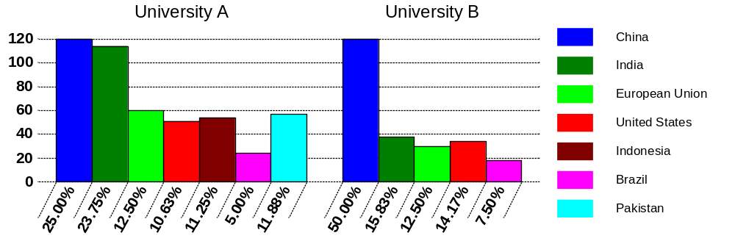
- Enhanced bar chart
- Limitations
The following limitations have been identified during the work on this research project.
  - Number of users
Although the twelve users (six per data representation method) allowed for scientifically usable results, additional users could have consolidated them. In particular, this was the case for the comparison of percentage (see chapter 4.2) where the response times could not be compared since only one bar chart user correctly answered the questions.
  - Overall number
The findings in regards to the overall number have been less clear than expected (see chapter 4.3). This might be related to the two reasons outlined in the analysis. In order to achieve a more consolidated result, a future survey should make use of multiple bar charts for that particular survey question. The following additional bar charts should be used:
- Bar chart where the differences in overall number is lower (e.g. ration 1:1.2) (see left chart below)
- Bar chart which has less subsets (bars) for the chart with the higher overall number (see right chart below)
Figure 4 below shows two such bar charts. Larger studies should in any case be diversified by the use of such additional charts.
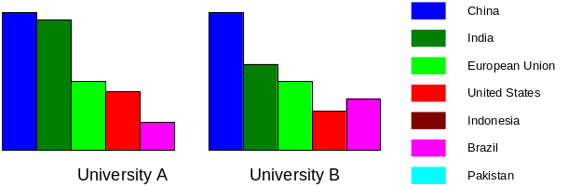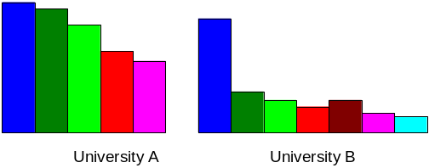
- Possible bar charts for additional survey questions
- Possible future work
In addition to work which mitigates the limitations described in chapter 6, further areas of possible future work have been identified.
  - Online survey
An online survey is still seen as a possible option, provided the following preconditions are met:
- A mitigation is built into the survey to filter out replies from users which did not understand how to read the charts. This could be achieved by post survey questions such as “I was puzzled why one pie was bigger than the other…”. A user who would answer with a “strongly agree” has probably not understood how to read the chart and his/her answers could therefore be excluded from the analysis. However, it is considered more difficult to identify such users in an online survey than in a face-to-face paper based survey where the moderator can also analyse the user’s gestures.
- A online survey tool can be sourced which allows to measure response time and hiding of the charts (the found freely available tools would have allowed the user to go back resp. scroll up to the chart).
It would be interesting to compare the outcomes of an online survey with the results of this research project.
  - Different data representation methods
During the work on this project, other variations of pie charts and bar charts have been observed in practical application. For instance, one variation used a bar chart where the bar height represented the number and the bar width the percentage (see Figure 5Figure 5) Future work could do studies on this approach. It is assumed that this variation is relatively unknown to users and further studies could therefore also research the influence this has on the usability of the chart.
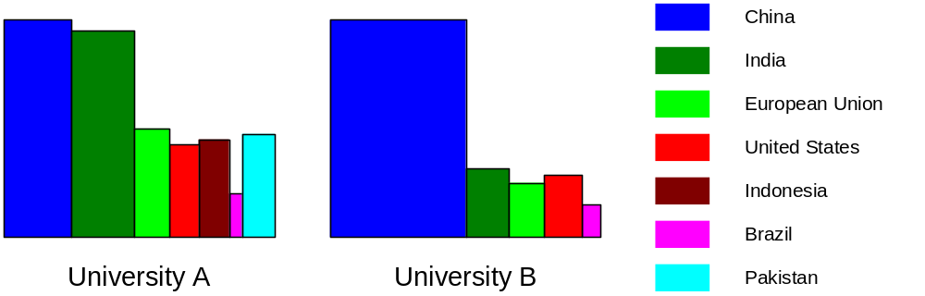
- Application of alternative bar chart on test data.

- Reflections
This chapter presents some of the learning’s made during the work on this research project.
  - Type of survey
The decision to use a paper bases face to face survey instead of an online one has proven to be a good one. This was highlighted by the fact that some of the survey outcomes would have not been achievable with the freely available online survey tools. For instance, the small difference in regards to the efficiency to present overall numbers could only be highlighted by the response time (see chapter 4.3). This could have not been measured in an online survey.
Learning
The applied method for data collection must be able to collect all the needed information, otherwise an alternative needs to be found.
  - Preparation of survey
The previous reflection highlights the fact that even more research should have been done during phase 1. In particular, additional pilot tests should have been conducted and the freely available online survey tools studied in more detail.
Learning
A proper preparation is indispensable and can save a lot of rework and time during later stages of a research project.
  - Other reflections
Some other reflections:
- Only a small fraction of the overall time has been spent on the execution of the survey. The vast amount of time went into the planning of the survey and the analysing and documentation of the results.
> Learning: Research is much less “hands on” work than expected.
- One user noted that the colours of the pies have been similar (e.g. light green and dark green). This seemed to be more obvious on the printout given to the users than on the pc screen.
> Learning: Other, more distinguish colours should be chosen for the data subsets. Check the artefacts given the users more carefully.
- One pie chart user (who did not know that there was also a bar chart survey) has noted that a “Comparative study with other type of data representation, may reveal more results”.
> Learning: This reply was a confirmation that other students thought along the same line. Also, it indicated that it would have been beneficial for both parties to discuss the survey with every user.
- References
Purchase, H. C. (2000). Effective information visualisation: a study of graph drawing aesthetics and algorithms. Interacting with Computers, 13(2), 147-162.
Dolnicar, S., Laesser, C., Matus, K. (2009). Online Versus Paper: Format Effects in Tourism Surveys. Journal of Travel Research, 47(3), 295-316.

